
Maize Analytics

How do I delete a VIP?

- Click the Manage VIPs link on the dashboard title.
- Scroll down and find the VIP you would like to delete.
- Click the checkbox next to the employee.
- Move your mouse over the row and choose delete.
The same process can be used to delete a Watch List Employee.

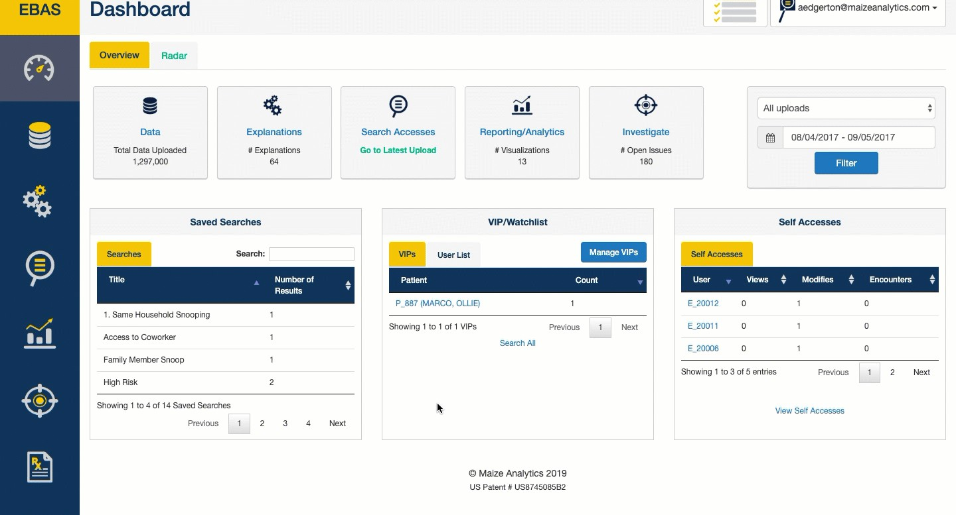

https://support.maizeanalytics.com/portal/en/kb/articles/how-do-i-delete-a-vip

